Captions and sources (Thomas Buhler)

Image number | Title | Caption | Source | Visualisation
Image 1 | "Maso" | Entrance of the "Meet Factory" (artist's residence) in Prague-Smichov | Personal picture | 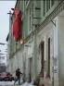
Image 2 | "Urban sprawl" | Urban sprawl in metropolitan Lyon's area from year 1955 to 1999 | Agence d'Urbanisme de Lyon (UrbaLyon) | 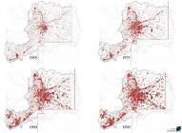
Image 3 | "St-Jean des Jardins" | Parking practices in Saint-Jean-des-Jardins, first french sustainable neighbourhood in Chalon-sur-Saône | Personal picture | 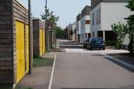
Image 4 | "Design and Practices" | Interactions between urban design and planning, together with social mobility practices | Personal diagram | 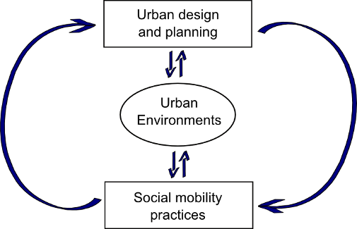
Image 5 | "Lyon Skyline" | Overview on Lyon's downtown from the Hill of Fourvière (West Bank of Saône) | Personal picture | 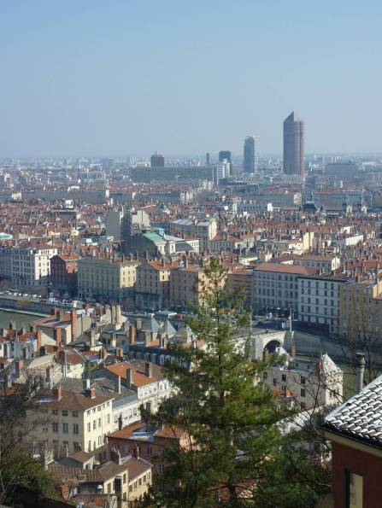
Image 6 | "Three circles" | Research framework joining urban environments, perception and practices | Personal diagram | 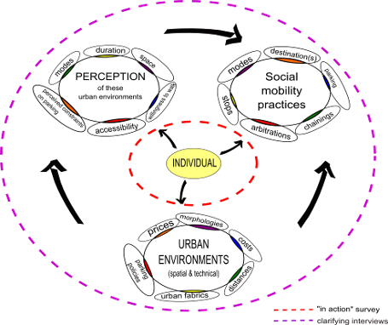
Image 7 | "Irreversibility" | Irreversibility versus interest for parking planning issues in the process of planning | Personal diagram | 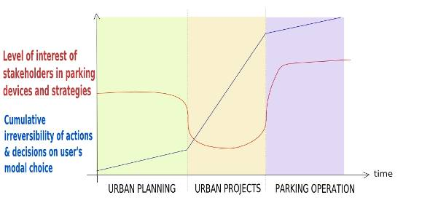
Image 8 | "Confluence project" | Lyon Confluence project. Stage I in colour is structured around a commercial centre in yellow and the banks of the river Saône (the second stage is in white). | Personal map (picture Google Earth) | 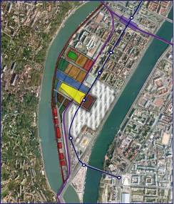
Image 9 | "Vélo'V" | Vélo'V (opened in 2005) was linked with a car-transit limitation in historical centre. | Personal picture | 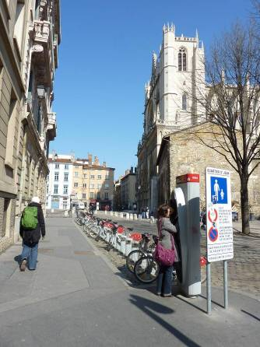
Image 10 | "Dictaphone" | In order to be closer to a certain reality of car travels which aren't considered by quantitative survey, we will use handheld recorders in action. | Personal picture | 