TeMA
Journal of
Land Use, Mobility and Environment

TeMA 1 (2012) 49-62
print ISSN 1970-9889, e- ISSN 1970-9870
DOI: xxxxxxxxxxxxxxxxxxxxx

review paper. received 12 March 2012, accepted 10 April 2012
Licensed under the Creative Commons Attribution – Non Commercial License 3.0
www.tema.unina.it

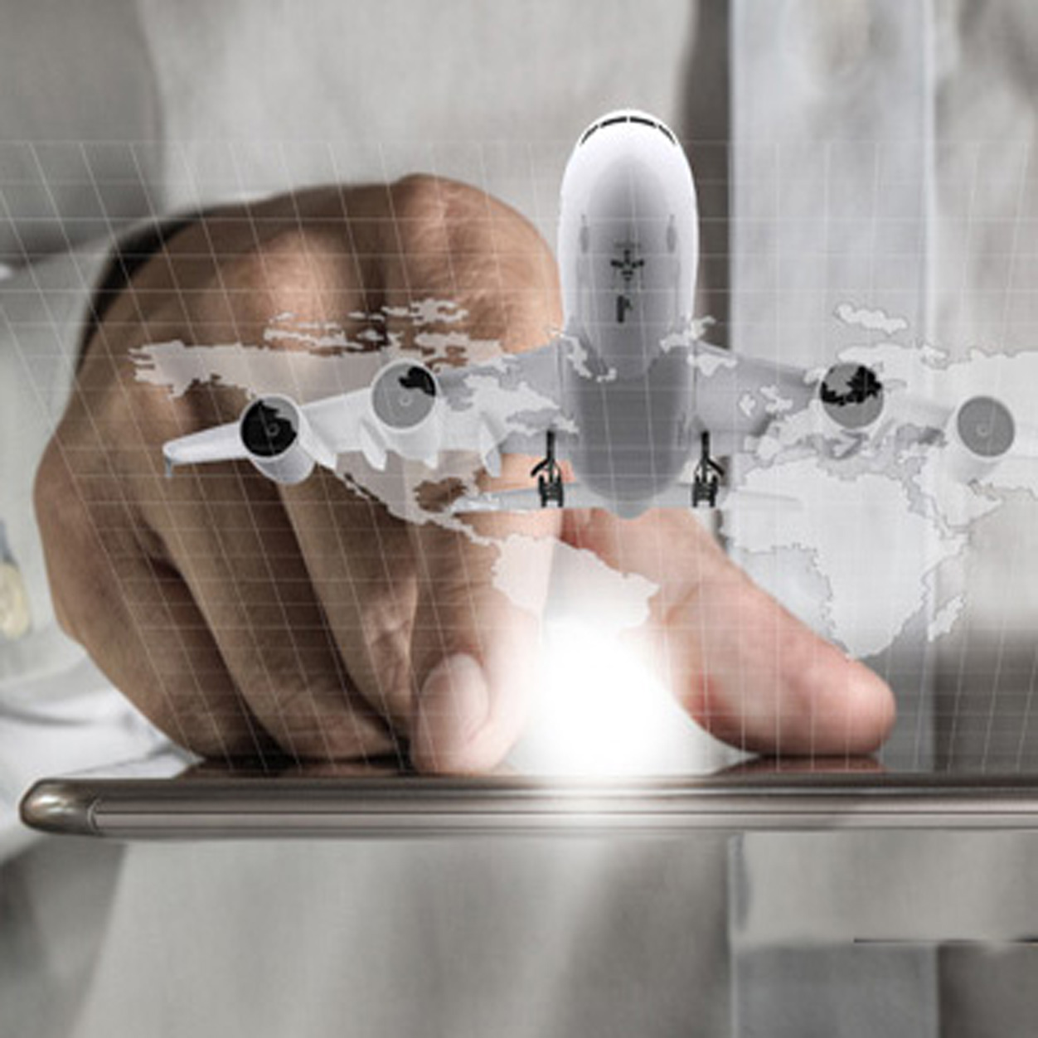  TOURISM AND CITY  REFLECTIONS ABOUT TOURIST DIMENSION OF SMART CITY | ABSTRACT  The city of the future seems to be forcibly “intelligent” both in physical and in the functional aspects.  This paper starts from the consideration that the diffusion of new communication technologies (ICTs) are significantly changing the urban supply system of tourist services giving rise to new ways of enjoying the city.  As tourism can be assumed as an urban activity, by a town planning point of view, the study of tourism is meaningful to identify development trajectories of the present cities oriented toward sustainable and smarter models. As a matter of fact, almost all the projects to get a “smart city” are based on the idea of joining the potentialities of ICTs and the needs of urban management through people living or using the city. In such a vision, “tourist dimension” of the city becomes fundamental in promoting urban image as well as in improving efficiency of the city. This efficiency also depends on the capability of each city to share historical and cultural heritage as “common good”.  As tourist demand has deeply changed also driven by technological development, this paper tries to investigate how will change the urban supply to meet the rising demand of quality and efficiency. The transition to smart tourist destination currently seems to be strongly connected with the number and the variety of apps to improve the “experiential component”. A lack of interest there seems to be in finding strategies and politics oriented to plan the urban supply of services tourist or not.  This consideration, if shared, opens up new perspectives for research and experimentation in which city planning could have a key-role also in proposing an holistic approach to city development towards smart city  KEYWORDS:  Smart city, digital tourism, town planning
ROSA ANNA LA ROCCA
Department of Civil, Architectural and Environmental
Engineering (DICEA) – University of Naples Federico II
e-mail: larocca@unina.it
URL: www.dicea.unina.it
1 Tourism and city
At present, city has become one of the tourist destination par excellence (Page and Hall, 2003).
The presence of cities into the “tourist experience” shows the transformation that has been increasingly affecting the tourist demand.
Indeed contemporary cities have become the object of tourist desire thanks to a renewed recovery of their condition of “being cities”. It is no longer the city seen only as a container of precious objects and valuable sites that attracts tourists, but the city system (Amendola, 1999). In other words, the “tourist city” product is the privileged place that contains either elements with great artistic, architectural, historical, value, or the peculiar cultural and traditional characteristics, or the opportunities of enjoying and taking part in events and occasions that allow tourists (temporal user of the city) get involved in urban life.
This new demand for city use has activated several strategies of urban promotion also because tourism is one of the leading sector of our economy.
The UNWTO data show an increase in this sector despite the crisis that has been affecting the most important west countries. In the last decade, in fact, the expense of international travels has doubled and it is expected to grow extra 50% in the next ten years (UNWTO, 2012).
Therefore, the competition among cities will be based also on the capacity of attracting big tourist flows, because of the undeniable positive effects on economic development. In Italy, for example, tourism contribution to the gross national product is 130 billion euro (about 9% of national production) and consequently it is defined as the leading sector of investment also in the political strategies of the present government (WTTC, 2013).
At the same time cities will have to be able to arrange adequate devices in order to contrast the negative effects produced by the uncontrolled development of tourism. The contradiction of tourism, indeed, consists in being contextually development factor and element which produces negative effects on urban liveability.
The challenge that tourist cities have to face consists exactly in their ability to find a balance between promotion and safeguard of their (historical, cultural, architectural, territorial, environmental) resources.
From a town planning point of view, this condition requires intervening through actions and policies targeted to the optimization of urban liveability. Moreover, a good quality of urban life is an unavoidable condition for building the future smart cities. At the same time, one of the factors of urban smartness consists exactly in making city attract tourists (investments, enhancement, image promotion, attractions of tourist flows, and so on).
Tourism, then, seems to represent one of the factors that shows the real accomplishment of the possibilities offered by the smart city concept.
Indeed, at a first glance, the attention in building the smart city seems to be paid only to the production of applications capable of improving the tourist experience also by involving the users in the mechanisms of city promotion. What seems to lack is an holistic vision which could allow, on the contrary, to face urban problems in an overall view.
Starting from the above-said assumptions, this paper investigates the aspects regarding the relationship between city and tourism pointing out the need for integrating tourist development and urban management. The several opportunities given by the ITCs tools have greatly affected the communication mechanisms as well as the requirements of particular urban users represented by the tourist demand.
Cities will have to provide with structures and services for meeting this demand efficiently and effectively.
This paper aims to show that in order to pursue this target it is necessary to reorganize the urban supply, which should be able to join the several aspects of the tourist demand (safety, mobility, accommodation, and so on) with the organization and liveability of the urban system.
Therefore, the paper is divided into three parts. The first part describes the elements which define a smart city, through a short review of the recent literature in order to stress that tourism is one of the smart city dimensions. The second part tackles briefly with the aspects regarding the changes of the tourist demand and urban supply in order to point out the present trends underway. The third final part includes some reflections on the possibility that the integration between tourist development targets and the town planning needs could offer in defining the urban smartness.
2 All the cities aim to become “smart”
The huge amount of funds made available by the European Union (in 2009 through the European Community Smart City and Communities Initiative) and in Italy by MIUR (in 2012 through the announcement Smart Cities and Communities and Social Innovation) for working out “strongly innovating solutions” for the regions development and the enhancement of the quality of life in the cities, has attracted the attention of business, public research authorities, universities and public administration, who have been asked for integrating their respective competences in order to set up projects for developing “smart cities”
The challenge consists in making cities more efficient as regards better quality of services, reduction of environmental impacts (polluting emissions), control of energy consumption, by means of innovating technologies (ICTs) capable of supporting the management, monitoring and functioning of cities.
Actually, it could seem to be not different from what has been already affirmed by some scientists in the Eighties and Nineties about the crucial change that new information and technological technologies had produced, prefiguring the “death of distance” (Cairncross 1997), the transition from the “city of atoms” to the “city of bits” (Mitchell 1996) or the most futurist “anything-anywhere-anytime dreams” (Graham 2004).
Maybe what they miss was the complementary –more than the substitutive– role of new technologies in developing urban activities on several (economic, social and physical) levels.
On the contrary, this concept represents the essential innovation of the emerging idea of smart city, where citizens and city users play an active role both as “detectors” and “diffusers” of data and information.
Indeed, the interaction between users and decision-makers represents one of the key points on which the idea of smart city is based, even if an univocal and shared definition has not been reached yet in Europe and all over the world.
For example, the report worked out by Cittalia titled Smart cities in the world collects twelve cases of innovative strategies activated by European and American cities, representing a “guide handbook” for technicians and decision-makers.
Whereas, The Top 10 Smartest Cities on the planet is the classification worked out in 2012 by Boyd Cohen, researcher at University of Colorado. It is based on some indicators (economy, environment, government, way of living, mobility, people) that compare the most important cities of the world. Stand in the ranking six European capital cities (Vienna (1°), Paris (3°), London (5°), Berlin (7°), Copenhagen (8°), Barcelona (10°) where investments in innovation are mainly targeted to set up measures for reducing climate changes.

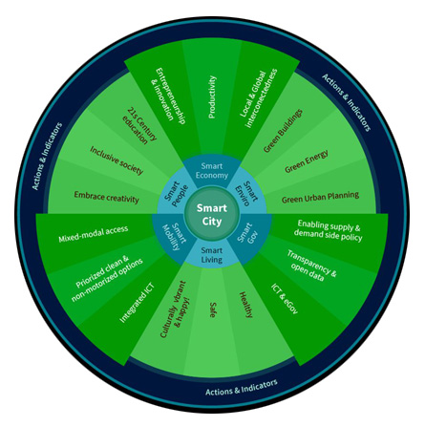
Fig.1 The wheel of smart city elaborated by Boyd Cohen

The recent report elaborated by European House Ambrosetti on Smart Cities in Italy shows that the definition of “smart city” can transform as the proponents change (fig. 2).
Sustainability is present in each proponents (institutions, academia, business) while the ICTs component is very significant for companies, which consider “smart cities” as an open lab for the application of innovative services and products. Even more, the attention to the “sensors” capable of making cities smarter seems to prevail, in spite of academics and professionals recommending not to underestimate the “smartness” concept by enhancing the role of technologies.
The “iceberg effect” (Bolici e Mora 2012) is a high risk, mostly encouraged by the ICTs leader companies which encourage the use of technology by standardized “smart” applications, lacking in a definite planning of development and application which should take local peculiarities into account (Townsend 2012).
The trend to encourage the operating implementation of technology is still predominant, also because a theoretical reference has difficulty in coming out (Fistola 2013).

 | Mobility | ICTs | Environmental Sustainability  (energy buildings ground water) | Quality of life | Smart society  (education, health, governance)
Istitutions
EU SET plan |  |  | ●
EU SC and Communities Initiatives | ● | ● | ●
Italian Digital Agenda | ● | ● | ● | ● | ●
MIUR calls | ● | ● | ● |  | ●
University
Wien University | ● | ● | ● | ● | ●
MIT SENSEable City Lab |  | ● | ● | ● | ●
Harvard | ● | ● | ● | ● | ●
Companies
ABB | ● | ● | ● | ●
Alcatel | ● | ● | ● | ●
IBM | ● | ● | ● |  | ●
Siemens | ● | ● | ●
Cisco | ● | ● | ● | ● | ●
Accenture |  | ● | ● |  | ●
Fig. 2 Definition/interpretation of smart city according to the typology of proponents, elaboration by ABB Ambrosetti (2012)

Also the reference to sustainability, incited by the environmental emergencies to be faced everyday (energy crisis, climate changes, and so on could represent a “risk” of trivialization in a way.
Therefore, like the sustainable city also the smart city finds it difficult to define a global view that would not be applied only to single parts (smart building, smart district, smart street, smart infrastructure, etc.).
Nevertheless a point of convergence seems to be found in the idea that a “smart city” should refer inevitably to an holistic concept able to join the positive aspects issuing from technological development with the qualities of the “social capital” (Papa, Gargiulo and Galderisi 2013; Fistola 2013).
Indeed, more and more often the availability of a good level of human capital is considered as a factor of competitiveness and territorial capacity of attraction (Florida 2003).
The basic concept refers to the opinion that in a smart city the investments in human and social capital and traditional (transport) and modern (ICT) communication infrastructure fuel sustainable economic growth and a high quality of life, with a wise management of natural resources, through participatory governance (Caragliu, Del Bo andNijkamp 2011).
On an extreme level, it could be argued that in the definition of smart city there are two interpretative models: the digital city and the eco-sustainable city, which evolve, get stronger and integrate each others supported by a third element that is the social capital.
The active role of the human factor (the anthropic system: the urban actors, residents, city users, tourists) is becoming increasingly important also because it can significantly affect the “destiny” of a city.
Therefore, the challenge of the smart city seems to be once again the (intelligent) attempt to make a city more competitive basing on the presence of factors which contribute to its “smartness” (the presence of a creative class; high levels of multimodal accessibility; high quality of transportation network; great diffusion of ICTs; high quality of human capital).

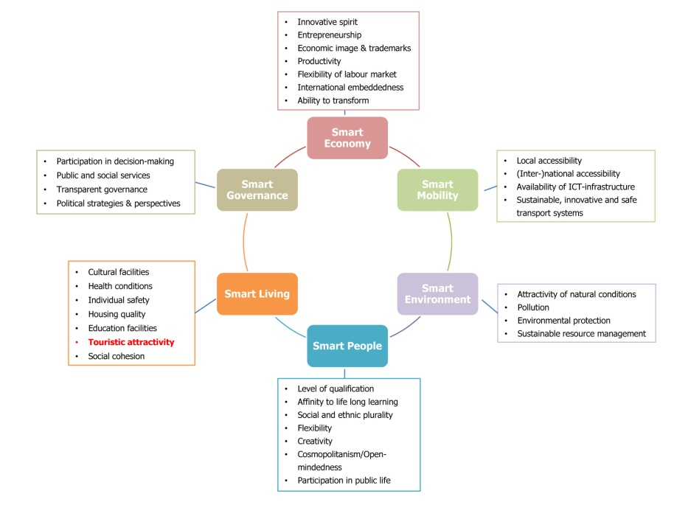
Fig. 3 Factors and indicators of the Smart City Index elaborated by Wien University: touristic attractivity is one of the factors of the “smart living”

The Smart City Index (fig.3), for example, promoted by the Wien University of Technology, University of Ljubljana and Delft University of Technology evaluates a sample of seventy European medium-sized cities characterized by: urban population between 100.000 e 500.000 inhabitants, presence of almost one university seat; catchment area less than 1.500,000 inhabitants (to exclude cities which are dominated by a bigger city). The ranking is based on the by now well known six dimensions of smart city: smart economy, smart mobility, smart environment, smart people, smart living, smart governance. These six dimensions have been built on the ‘smart’ combination of endowments and activities of self-decisive, independent and aware citizens.
Tourist attractivity is one of the factors which define the “smart living”. In the ranking, this factor characterizes the Austrian cities (Salzburg, Innsbruck, Graz, Linz) and the Belgian ones (Brugge, Gent).
Thus, tourism appears among smart city dimension and it is considered as a factor able to concur to a “smart living”. Probably this is because tourism is a real economic resource for many city: it produces income, it generates jobs and skilled labour force, it is often the main element to activate projects of urban requalification, it attracts investments and stimulates local business entrepreneurship, and so on. Briefly there are a lot of positive effects of tourism development from an economic perspective.
At the same time, tourism has also negative impacts on urban life: environmental and noise pollution, over-load capacity, traffic congestion, functional mingling and so on. This dual aspect characterizes the tourist phenomenon and pushes the need to integrate tourism and town planning in order to maximize the positive effects in urban living. At the present, however, there seems to be still a lack of attention especially in town planning sector. In other words only if correctly planned, developed and efficiently managed, tourism can be a catalyst for a vigorous economic development and social progress in city. As shown in the next section, it seems that tourism destinations tend to use “innovation” almost entirely as a vehicle for developing new products or apps even though this is to upgrade the quality of urban services and improve competitiveness between cities. Within this context the concept of “smart city” seems to be reduced. On the contrary, cities have to recognize the changing occurring in tourism demand and set new priority areas for action.
In this sense urban planning research could give a valid contribution in building up tourist smart city where residents needs and tourist demand meet.
3 from tourist city to “Smart destinations”
Cities are going to become more and more the place of crucial challenges that human beings will have to face (Vianello 2013). It is in the cities that the most important challenges are played for hitting global targets such as the mitigation of climate change and the improvement of social inclusion (Testa 2012). It is from cities that the -energy, environmental, economic, cultural- crises have arisen and it is again in the cities that the possible solutions are to be found. Cities are both cause and solution of the crisis: they are the cause because they gather consumption and waste of energy and resources, and they are also the solution because they gather the research and experimentation activities.
Also in contrast with the most catastrophic expectations, according which cities would have been a “worthless heritage of the past” (Gilder 2000), cities still go on increasing their inhabitants and users.
The “city appeal” as place where all the opportunities for “being protagonists” is affecting also the choice of tourist destination: therefore cities have become one of the preferred places of the present tourist demand. As regards the peculiarities of the present tourist demand, in fact, the availability of attractions or amenities is not enough, but it is necessary to create an heterogeneous supply (resources, services, attractors, and so on) in order to meet the ever-increasing demand for quality characterizing the present tourist users (La Rocca 2003).
The “tourist product”, in fact, consists in a structured system of interacting elements (goods, services, information, attractions, cultural elements, environmental emergencies and so on) that form the “supply system”. The peculiarities and qualities of this system affect the choice of a destination and produce a competition among the different tourist destinations (La Rocca 2010).

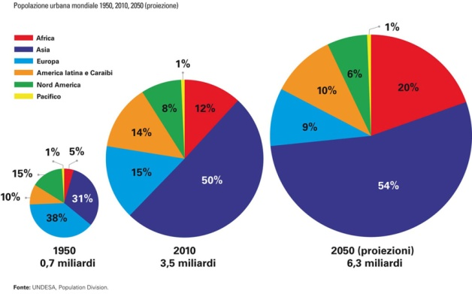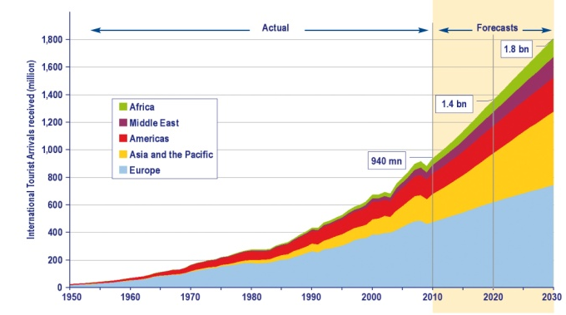
Fig. 4 The increasing urban population trend (left) and the tourism forecast 1950-2030 (right) by UNICEF and UNWTO

The strategies for developing and promoting a region in tourist key are based just on the capability of organizing the supply of goods and services (for tourist support) according to a complex system able to improve the overall “tourist experience”.
The reference to the city as experiential tourist product refers also to the systemic-dynamic dimension of tourism, mostly investigated by the European and Anglo-Saxon schools of thought.
According to the above said view, city has become one of the most favourite tourist destinations, thanks to the possibility of using, in the same place, a great variety of elements that increase tourist experience, namely, of meeting the emerging tourist demands (Spirou 2011).
The “experiential component” represents one of the latest evolutions within the disciplines which study tourist phenomenon. This component is represented by elements able to enhance the value and to differentiate the supply system, mainly in relation to those elements capable of “making tourist experience unique”. Unlike the global tourist product, the “experience product” is not the sum of attractive factors, but the ability to make the holiday unique by producing emotions.
The challenge involving all the present cities that aim at being international tourist cities consists just in the capability of working out supply systems, which are more original than the traditional supply of goods and services.
In the smart city, this condition is strengthened by the attempt to enhance the supply tourism-supporting services through more and more innovative applications, which transform tourists from simple observers to the leading actors of their visiting experience.
The risk of trivialization and homologation is still lurking. Actually, it is possible that by attempting to make tourist supply spectacular, it could end up by standardizing it and by emphasising only some factors that have almost nothing to do with the enhancement of the city and its resources and culture heritage.
Nevertheless, the transition from the “vacation spot to smart destination” (Sanchez Chillon 2012) has already taken place.
There are infinite possibilities of innovative applications (apps) able to support the tourist in the use and knowledge of the city he wants to visit. Indeed, if the definition of smart city seems to be confused, the one regarding the smart destination is still less defined, where the technological factor seems to prevail on all the others.
At present the urban supply for tourists seems to be addressed almost only to enhance the technological applications to improve tourist experience. Many present cities are trying to put themselves as alternative tourist destination also because of the original supply of urban system use. They pass from the construction of dedicated routes “supported” by QR codes capable of recreating movies scenes (New York, London and Paris) to the applications of Augmented Reality allowing either to “travel across time” and to watch the original conditions of a monument or an archaeological site (Rome, Athens) or to recreate the atmosphere that have made some places famous (Paris, London), or to be virtually inside an open air museum (London and Barcelona). Street Museum, for example, is the Augmented Reality (AR) app of the Museum of London that lay upon the real image some historical pictures of London streets, allowing the visitor to “live” some decisive moments of the city history, such as the Great Fire of 1666.
As previously said, the applications can be unlimited and they are undoubtedly changing the way of interpreting the supply of tourist-supporting services affecting also the ways in which visitors use cities.
The interest shown by market operators is extremely strong also due to the fact that market analyses allow to set up marketing strategies targeted to catch the user preferences and needs (fig 5).

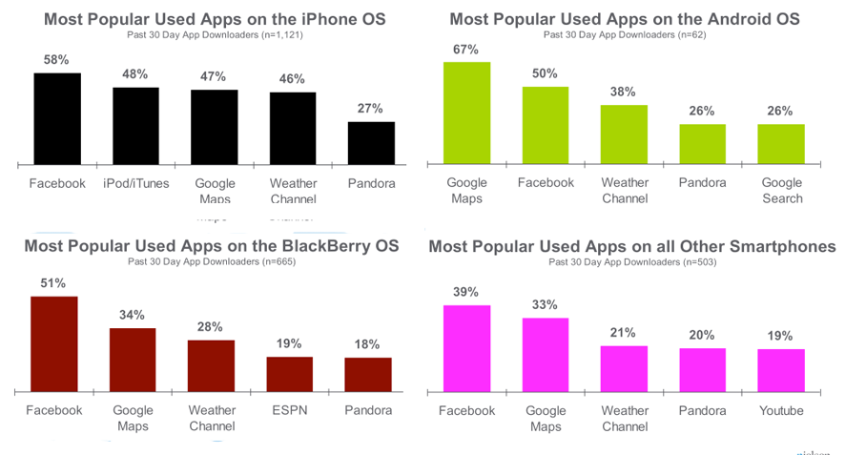
Fig. 5 Utilization rate of the most popular apps for smart phone

On this subject there are many scientific studies that point out the interactions between intelligent systems and tourism (for instance the Laboratory for Intelligent Systems in Tourism – LIST University of Wollongong, Australia). In a recent study (Heather Kennedy-Eden and Ulrike Gretzel 2012), a taxonomy of mobile application in tourism has been proposed referring on one hand to service provided, on the other hand, to the level of user customization.
The study considers apps available prior to July 2011. By using a phonetic approach for building the taxonomy of service provided, seven categories of travel-related apps emerged: Navigation, Social, Mobile Marketing, Security/Emergency, Transactional, Entertainment, and Information. Each category is then subdivided into sub-categories made different according to the service provided by the app (fig. 6). Although being not exhaustive and susceptible to further improvements, this taxonomy allows to look at the way in which the tourist-supporting services are changing and how this element of the supply system strongly affects the visitor’s choices.
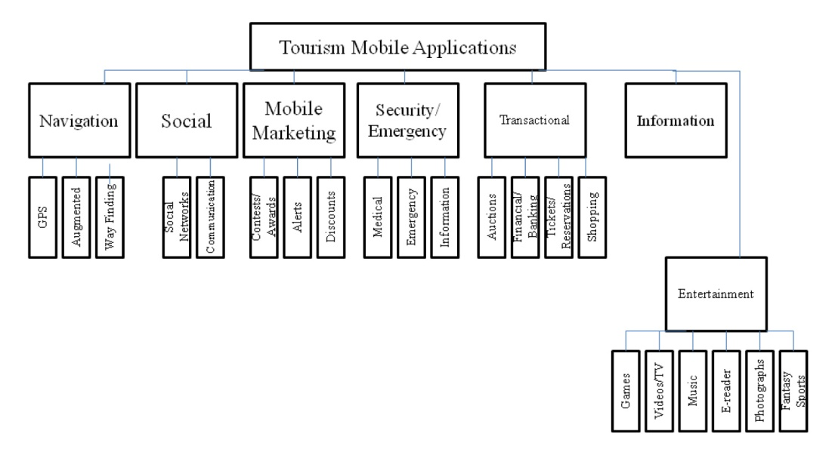
Fig. 6 Taxonomy of tourism mobile application by service provided elaborated by Kennedy-Eden and Ulrike Gretzel

On the other hand the possibility of “making virtual” the tourist phase of travel planning is not new. The use and spreading of the internet, mainly during the Nineties, have greatly changed the development of the pre-travel steps (Maguer 2011). The immediate effect on tourist system has been the drastic change of all the market segment devoted to intermediation. Travel agencies, for example, had to transform their structure and are probably destined to play a marginal role in the future arrangement of tourist sector. At the same time, tourist business had to change their promotion strategies in order to reach the ever-increasing demand segments. The cities aiming to become tourist destinations have been forced to join the network in order to become attractive and offer a charming representation of their resources in view of attracting tourist flows and competing on international level.
The e-tourism phenomenon derives from the possibility of using a “virtual” dimension of a given region or a city before moving to it, which also characterizes the development of tourist activity.
The introduction of mobile technologies has indeed changed this condition too. In effect it is possible to use “virtually” the object of the tourist desire (a destination or a specific site) although being physically present in the desired place. The applications of the augmented reality consist just in the possibility of projecting oneself into a virtual dimension by pointing one’s smartphone to the object “to discover” or to get information about what to visit, where to eat or to catch a bus and so on (fig. 7).

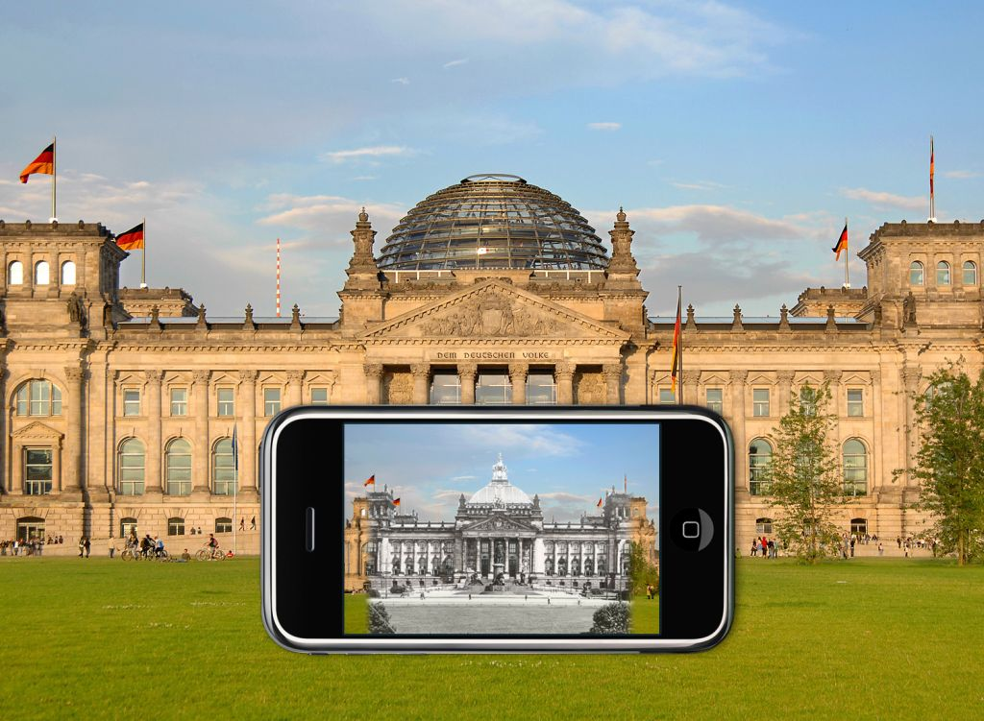 | 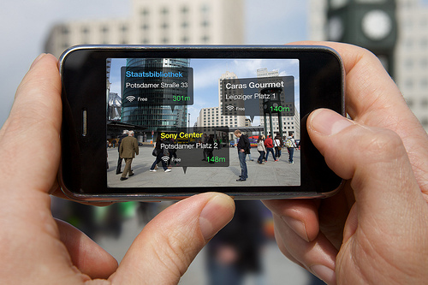
Fig. 7 Augmented reality apps allow to interact with the object of the visit

The internet connection does not require a physical place, but it can take place everywhere thanks to small devices available in every city (the wi-fi networks for example)
It is the transposition from e-tourism to m-tourism, a dimension where tourist becomes “mobile user”, namely he can be continually connected with any place and/or any community to exchange data and opinions in real time, participating actively in the choice of one destination instead of another.
It is approximately the mechanism of social networks, of tourism 2.0 based on the culture of sharing and participation (web 2.0). This sharing takes place in real time, during the travel experience and has radically changed the role of the tourist: from “consumer” to “”evaluator”. According to this view, the tourist’s role entails greater responsibility and it is just starting from this condition that the supply system, by the side of private and public operators, is changing its ways of spreading in order to retain more aware, careful and ever-connected customers.
In a short period of time, tourist demand has further increased: e-tourism has become “digital tourism” (SO-LO-MO social local mobile). A typology of tourist that apart from planning holiday with remote assistance (network) shares and communicates them (SOCIAL) through several applications, which strengthen his role of decision-maker-actor (tripadvisor, zoover, hotpot, etc.), allowing him to appreciate the possibilities of using the place he stays in (geo- LOCAL) by means of mobile technology tools (smartphone, tablet, ecc.) which are going to become more and more unavoidable (MOBILE).
4. tourism as perspective for further reflection on smart city planning reasearch
Tourism is one of the fields where the real achievement of the possibilities given by the paradigm of smart cities can compete. The competition among cities has to compare also with the ability of each city to attract tourist flows and investments in order to improve the supply system by exploiting new technologies.
What arises from the present scenario –characterized by radical changes both in the supply system and in the tourist demand one– is a substantial imbalance of the innovative element of the product (the apps) in improving the travel experience element.
On the contrary there is a less clear and scarcely investigation of the factor regarding the possible applications of ITCs in the management and reduction of the impacts inevitably produced by tourist activity in the urban planning field.
The urban tourist dimension seems to be still considered as “other”, namely not integrated in the organization of the city. Nevertheless “tourism and culture” are considered as one of the emerging dimensions of the smart city, apart from representing one of the research subjects promoted in Italy by the MIUR (Ministry of Education) to show the projects for Smart City and Communities (smart culture and tourism): “A smart city promotes its tourist representation as an intelligent presence on the web; makes its cultural heritage and its traditions virtual and put them on the internet as “common goods” for its citizens and visitors; uses advanced techniques to create thematic routes and maps of the city and to make them be user friendly; promotes a coordinated and intelligent supply of its tourist supply on the Internet; gives tourists an easy access to the networks and online services according to their requirements”.
A strategy that is still targeted to enhance services supply for the use of a city, or rather the component of the supply system able to affect the attractive power of a territory, and then still linked to the research of elements and conditions that make a city more competitive, although the reference to the concept of “common good”.
In the strategic plan for tourist development “Italy 2020” worked out in January 2013 (fig. 8) among the primary actions there are the indications regarding the improvement of tourist flows distribution with priority to the “top cities” (Rome, Venice, Florence and Milan), in order to reduce the risk of saturation caused by the high tourist concentration in those cities (Action 26).

Guidelines of the strategic plan | Targets-Actions in the sector
Governance | Enhancement of the central support and coordination
Relaunch of the tourism national agency | New project and reorganization of the mission
Supply enhancement | Definition of priority poles (30-40)
Improvement of accommodation capacity | Supply requalification and improvement
Transport and Infrastructure | Development and adaptation to the demand requirements
Training and expertise | Improvement of the supply quality carried out by the operators in the field
Investments | Setting up incentives and simplification of the procedures (zero bureaucracy)
Fig. 8 The Tourism Development Strategic Plan in Italy points out seventy actions clustered in seven guidelines targeted to recover the market shares of tourist demand

Nevertheless the interventions are based only on setting up measures for the selective reduction of the incoming flows in specific places (for ex. Entrance ticket) or for the best schedule of the events which mostly attract flows of visitors. While just a hint is given to the possibility of making tourist flows more sustainable for the functioning and organization of the city.
In this direction, the research of possible solutions seems to have still more chances of development, which should not be undervalued, since they allow to investigate aspects considered as marginal up to now in the field of urban disciplines.
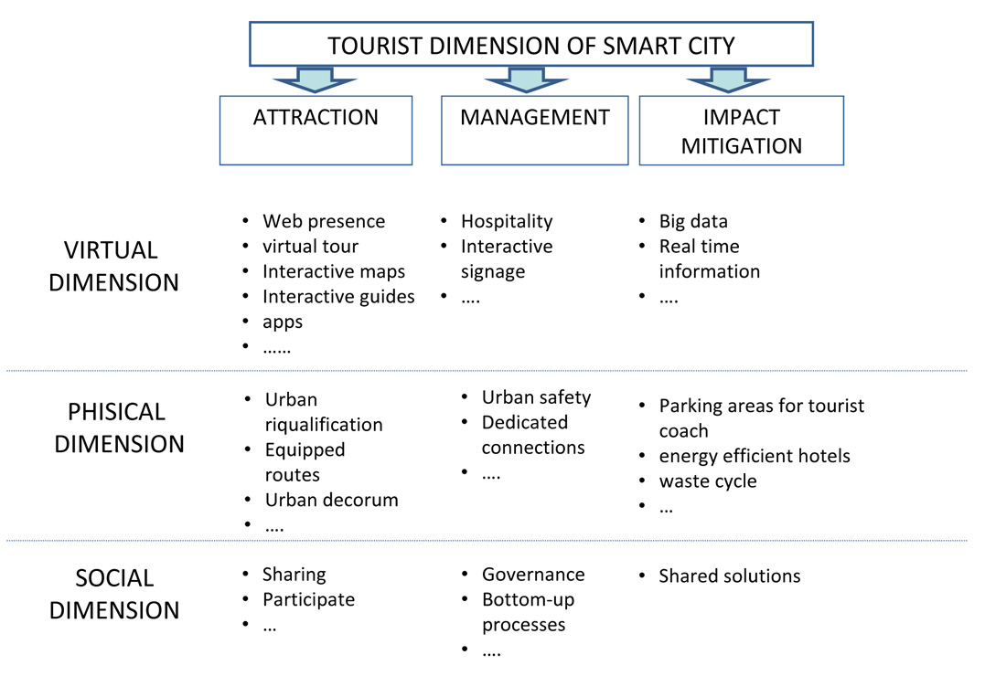
Fig. 9 Relations and impacts of tourist dimension on urban organization

The need for changing urban services supply, according to the emerging requirements expressed by an increasingly expert and qualified tourist demand, will inevitably ask for reconsidering the role of some urban functions modifying also the physical elements and the relationship with the urban context.
Railway stations, airports and ferry terminals, for example, represent the “new gates” to enter the city and are places meant to receive tourist flows and then to allocate them over the territory. Moreover in the urban area it could be possible to find some poles of excellence for delivering services to support tourists, which could be considered as “new poles of tourist reception”, an advanced version of the tourist office, which will inevitably modify its role and function.
The enhancement of tourist supply represents the main target of the development policies aimed at improving the image of a city and its competitive relaunch, but it cannot be based only on the realization of a supply of advanced services (virtual tourist guides, augmented reality, and so on). On the contrary, it should be the result of an accurate project of new functionalization and organization of urban supply, which should be capable of integrating the several dirextrices of tourist needs (security, mobility, accommodation, and so on).
This consideration, if shared, opens up new perspectives for research and experimentation in which city planning could have a key-role also in proposing an holistic approach to city development towards smart city.
REFERENCES
AA.VV. (2007), Smart Cities-Ranking of European Medium Sized Cities, Centre of Regional Science Wien Unioversity of Technology, available at http://www.smart-cities.eu
ABB Power and productivity for a better word European House Ambrosetti (2012), Smart Cities in Italia: un’opportunità nello spirito del Rinascimento per una nuova qualità della vita, available at http://www.abb.it and www.ambrosetti.eu
Bolici R. e Mora L. (2012), Dalla Smart City alla Smart Region. Governare la transizione intelligente delle polarità urbane, available at http://forges.forumpa.it
Cairncross, F. (1997), The Death of Distance. How the Communications Revolutions Will Chance Our Lifes, Harvard Business School Press.
Cohen, B. (2012) The Top 10 Smartest European Cities, Co.EXIST, http://www.fastcoexist.com/1680856/the-top-10-smartest-european-cities#1
EfficienCITIES. Città-modello per lo sviluppo del Paese, progetto di ricerca Siemens realizzato da Cittalia, available at http://www.swe.siemens.com
Fistola, R. (2013), “Smart city. Riflessioni sull’inteklligenza urbana”, TeMA Journal of Land Use Mobility and Environment, DICEA – Università degli Studi di Napoli Federico II vol 6, n. 1(2013) Smart Cities: Researches, Projects and Good Practices for the City, http://www.tema.unina.it
Florida, R. (2012) The Rise of the Creative Class, Revisited , Basic Books
Gilder, G. (2000) TELECOSM: How Infinite Bandwidth will Revolutionize Our World, Free Press, NY.
Gnudi, P. e Bergami, M. (2013), TURISMO ITALIA 2020 LEADERSHIP, LAVORO, SUD Piano strategico per lo sviluppo del turismo in Italia, Presidenza del Consiglio dei Ministri Dipartimento per gli Affari Regionali, il Turismo e lo Sport, Roma.
Graham S. and Marvin S. (1996), Telecommunications and the city. Eletronic spaces urban spaces, Routledge, NY.
Kennedy-Eden, H. and Ulrike G. (2012) “A Taxonomy of Mobile Applications in Tourism”, e-Review of Tourism Research (eRTR), Vol. 10, No. 2, 2012, http://ertr.tamu.edu
La Rocca, R.A. (2003), Turismo turismi e città, Dipartimento di Pianificazione e Scienza del Territorio Univbersità degli studi di Napoli Federico II Collana Dottorato e Giovani Ricercatori n. 2/2003, Giannini Editore Napoli.
La Rocca, R.A. (2011) “Mobilità sostenibile e stili di vita”, TeMA Journal of Land Use Mobility and Environment, vol 4 n. 2 (2011) Green Mobility, DICEA – Università degli Studi di Napoli Federico II, http://www.tema.unina.it
Maguer, A. (2011), Comment les nouvelles technologies valorisent elles le séjour touristique ?, Institute d’Aménagement de tourisme et d’Urbanisme,
Mitchell, W.J. (1996) The City of Bits, MIT Press Paperback Edition
Page, S.J. and Hall, M. (2003) Managing urban tourism, Pearson Education Limited.
Papa, R., Gargiulo, C., Galderisi A., (2013) “Towards an Urban Planners Perspective on Smart Cities”, TeMA Journal of Land Use Mobility and Environment, vol 6, n. 1(2013) Smart Cities: Researches, Projects and Good Practices for the City, DICEA – Università degli Studi di Napoli Federico II, http://www.tema.unina.it
Sanchez Chillon P. (2012) “From Vacation Spots to Smart Destinations: technology and tourism, qr, apps and augmented reality for cities”, Urban 360°, http://www.urban360.me
Spirou Costas (2011) Urban Tourism and Urban Change: Cities in a Global Economy, Routledge, NY.
Testa, P. (2012) ed Smart Cities nel mondo, Cittalia Fondazione ANCI Ricerche, available at http://www.cittalia.it
UNWTO (2012) Annual Report 2012, published by the World Tourism Organization (UNWTO), Madrid, Spain.
UNICEF (2012) Rapporto UNICEF 2012 "Figli delle città", http://www.unicef.it
Vianello, M. (2013), Smart cities. Gestire la complessità urbana nell’era di Internet, Maggioli editore.
WTTC (2013), Travel & Tourism Economic Impact 2013, World Travel & Tourism Council, London, UK.
IMAGES SOURCES
Fig pag XXX is from http://www.betybyte.com; fig. 1 is from http://www.boydcohen.com/; fig.2 is from http://www.ambrosetti.eu; fig.3 is from http://www.smart-cities.eu; fig. 4 is from www.unicef.it and from www.unwto.org; fig. 5 is from http://www.businessinsider.com; fig. 6 is from http://ertr.tamu.edu;fig. 7 is from www.en.wikipedia.org; other figures are from the author.
AUTHORS’ PROFILE
Rosa Anna La Rocca
Architect, PhD in Urban and Regional Planning, researcher at the Department of Civil, Architectural and Environmental Engineering (DICEA) - University of Naples Federico II. Her research activities refer to the analysis of phenomena that can change urban organization and they are focused on the study of three main relationships: tourism and town planning; land use and mobility, innovation technologies and urban transformations.

Born in the Ninety, the European project MOSAIC (Museums over States and Virtual Culture) within the programme TEN TELECOM of 1997 was targeted to realize the first network of virtual museums. The basic idea of the project consisted in making available, by using new technologies, also those parts of cultural heritage contained in few European museums not open to public.
Digital Tourism is defined as the digital support of the tourist experience before, during and after their tourist activity. http://sachi.cs.st-andrews.ac.uk/research/areas/digital-tourism/

