PLATES

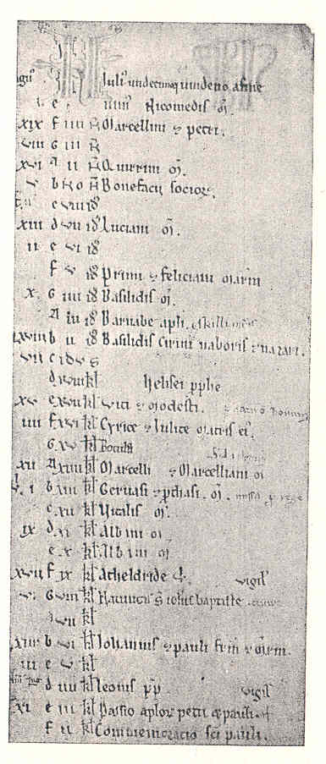
Plate 1. Vallentuna calendar (June).

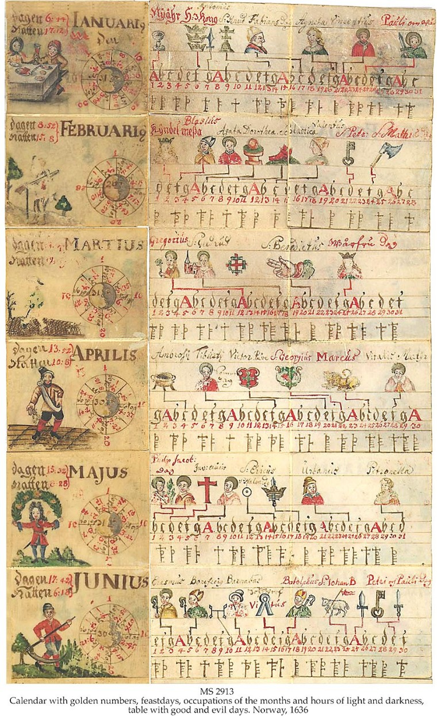
Plate 2. Folding calendar from Uvdal, Norway.

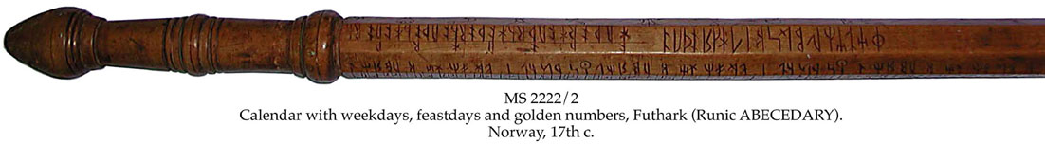
Plate 3. ‘Runstok’ (walking stick) from Norway.

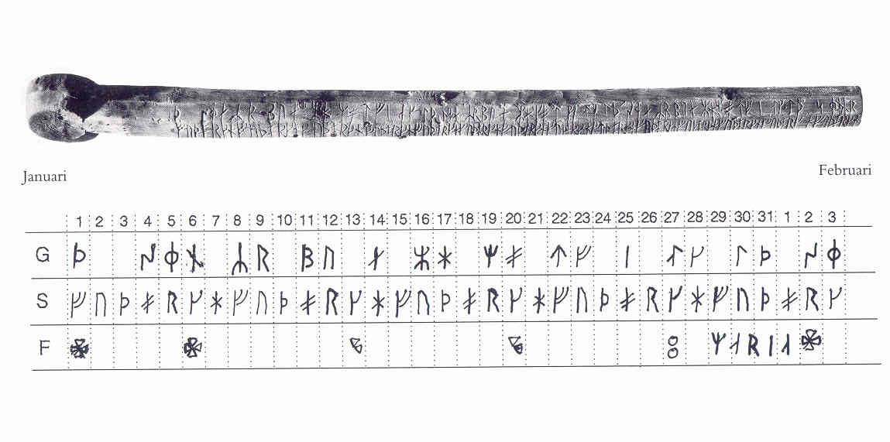
Plate 4. ‘Runstav’ from Nyköping, Sweden.

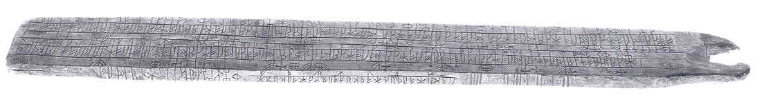
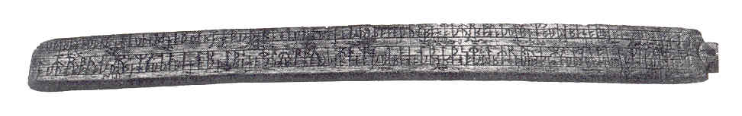
Plate 5. Two-sided ‘runstavar’ from Sweden.

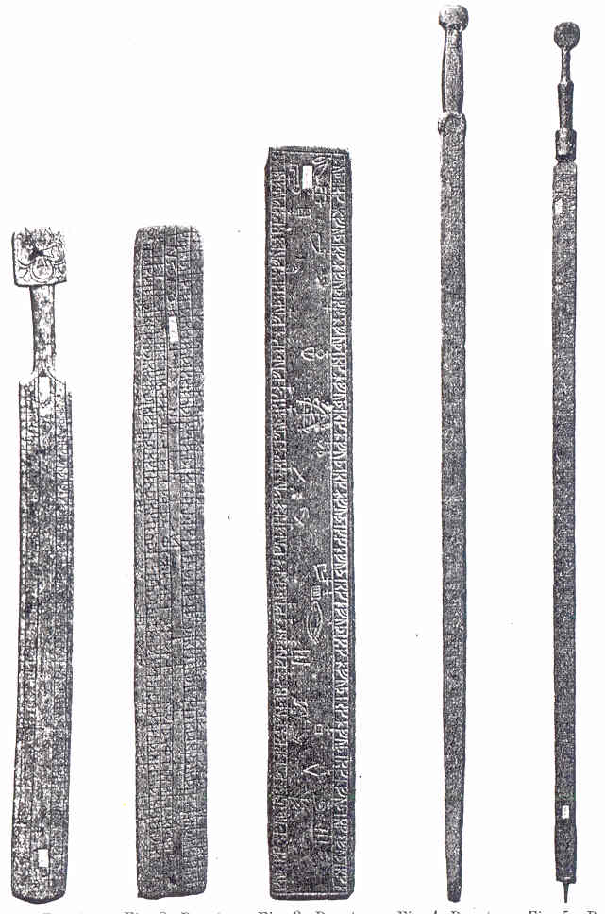
Plate 6. Different forms of runic clogs and staves from Sweden.
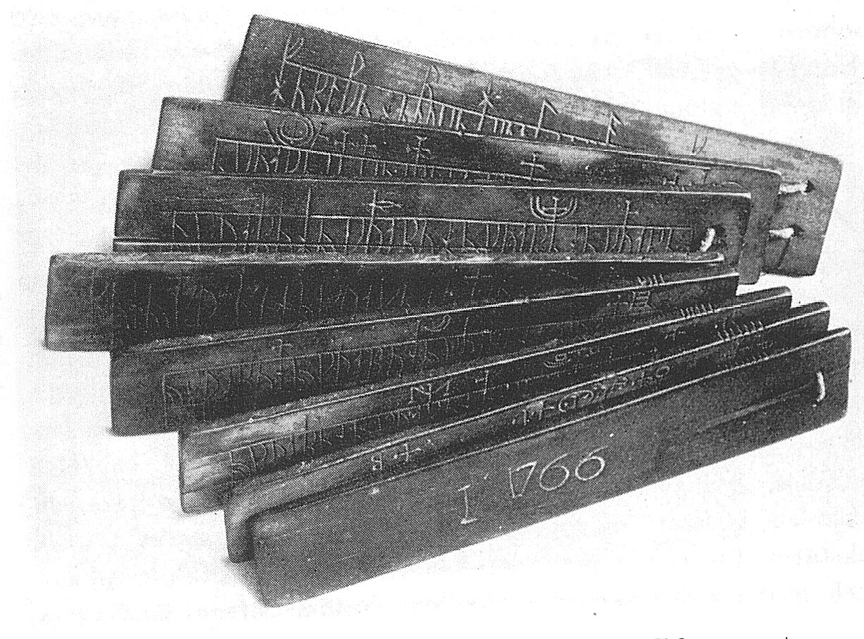
Plate 7. ‘Runbok’ from Gammalsvenskby, Russia

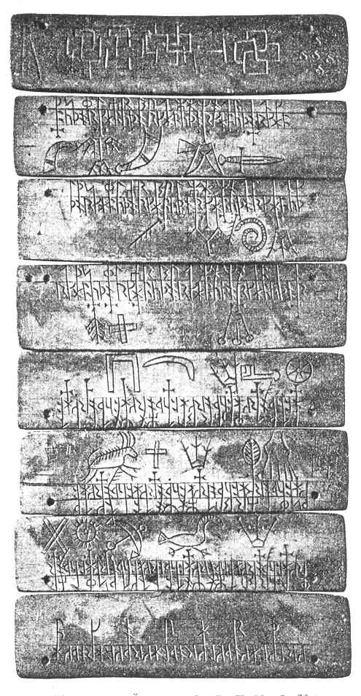
Plate 8. ‘Runbok’ from Östergötland, Sweden.

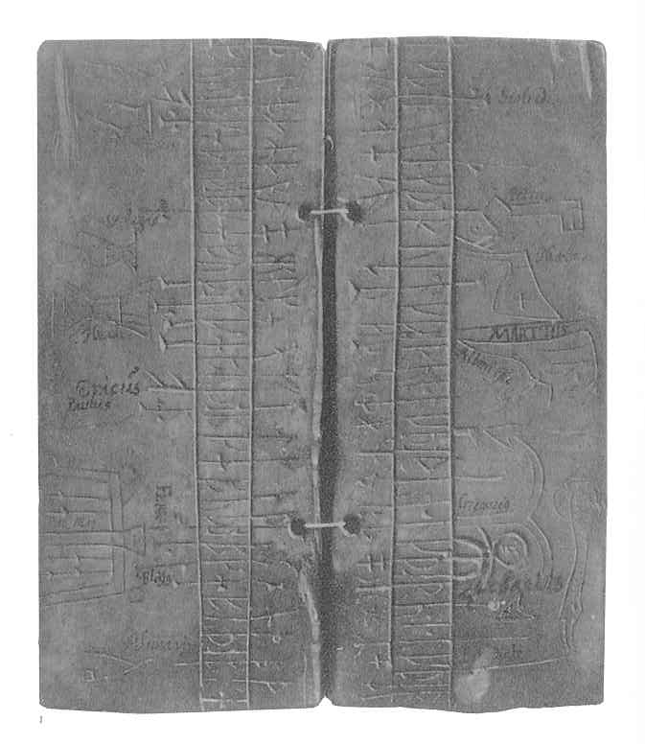
Plate 9. ‘Runbok’ from Öland, Sweden (January, 1st –March, 23rd)

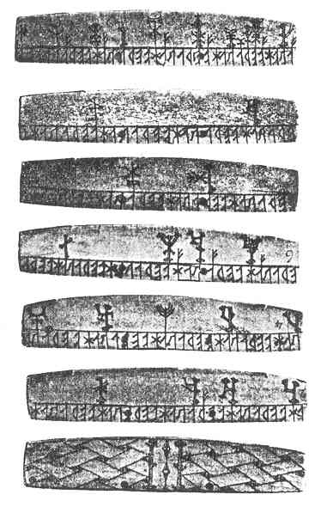
Plate 10. ‘Runbok’ from Lapland.

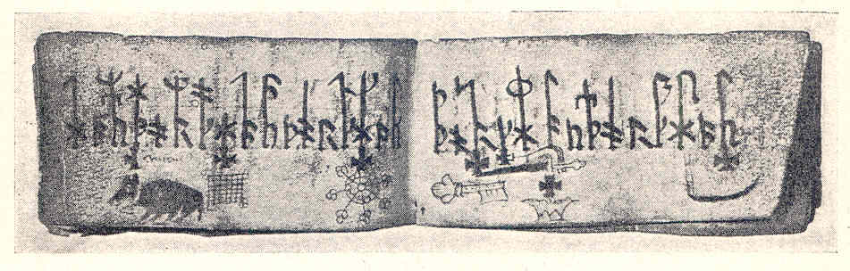
Plate 11. Parchment pocket calendar with runes from Östergötland, Sweden.

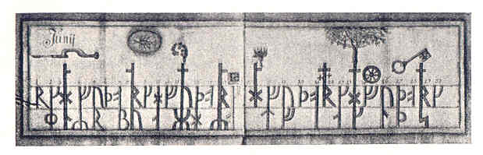
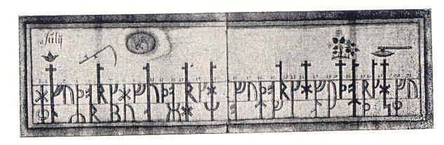
Plate 12. Paper runic almanac from Västergötland, Sweden.

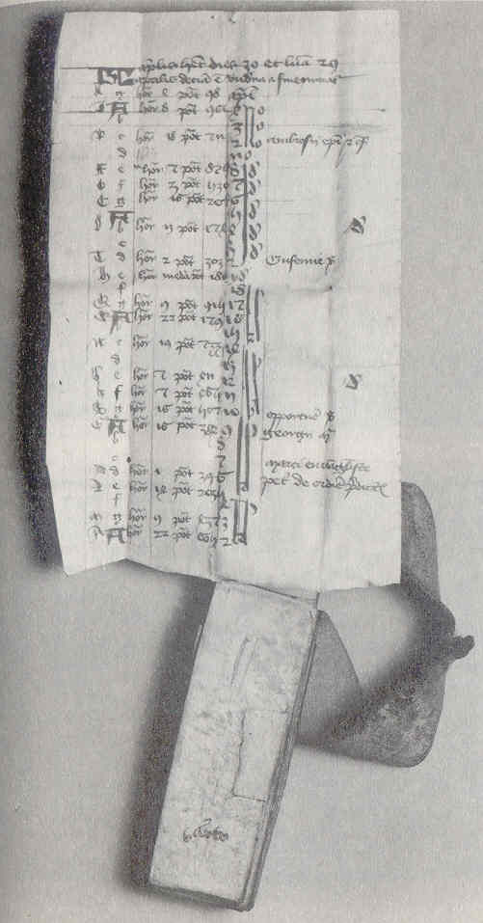
Plate 13. Parchment pocket calendar, France.

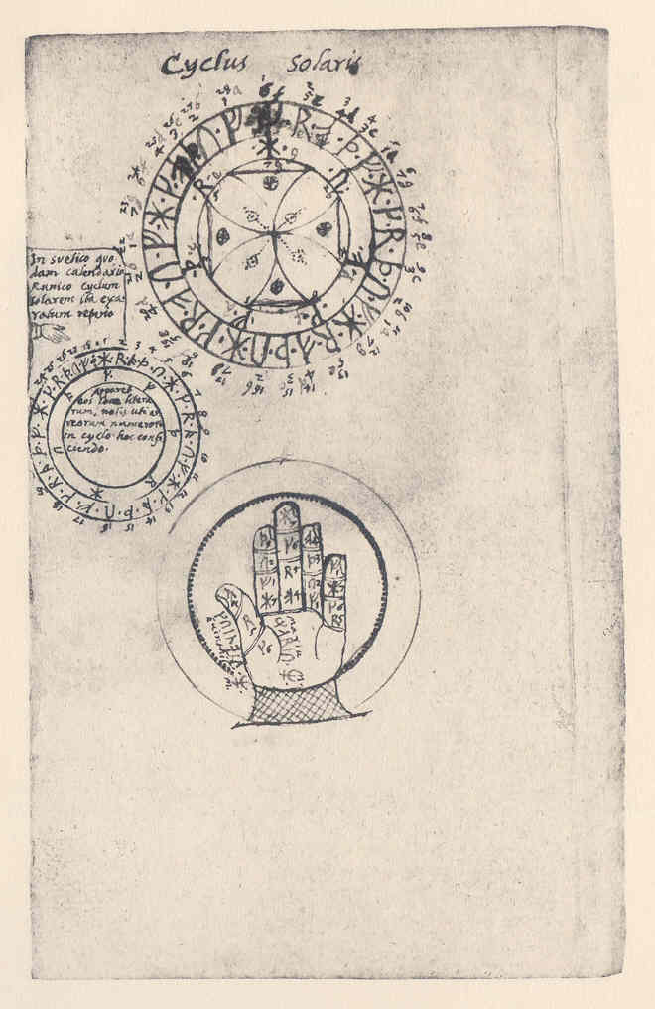
Plate 14. ‘Cyclus Solaris’ from Ole Worm’s copy of the Gotland runic calendar 1328.

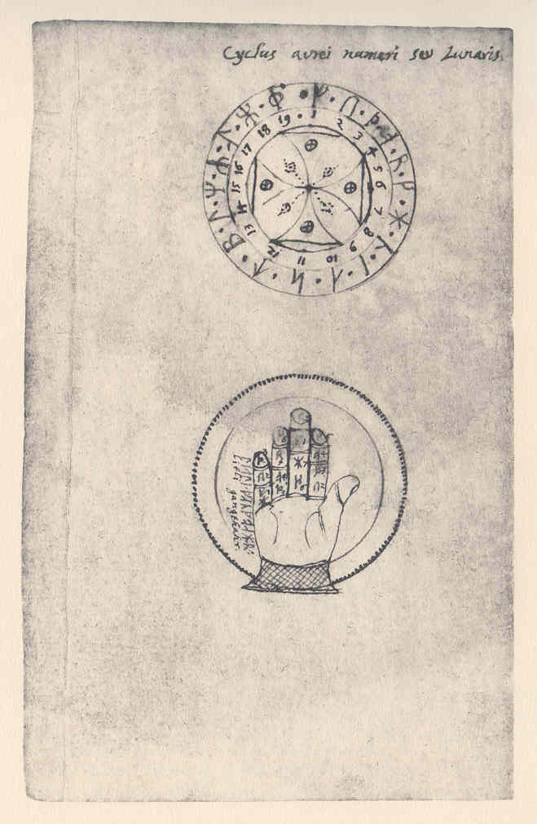
Plate 15. ‘Cyclus aurei numeri seu Lunaris’ from Ole Worm’s copy of the Gotland runic calendar 1328.
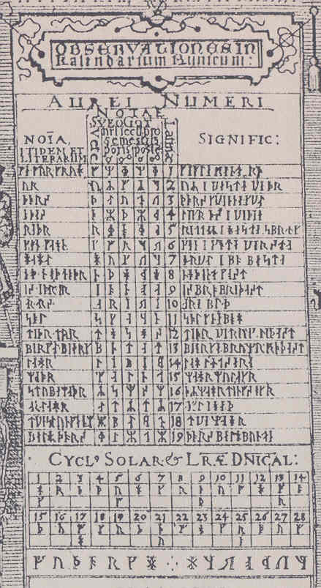
Plate 16. Detail from Johannes Bureus’ Runtavla (1600).
‘Observationes in Kalendarium Runicum: Aurei Numeri, Cyclum Solare & Litterae Dominicales’

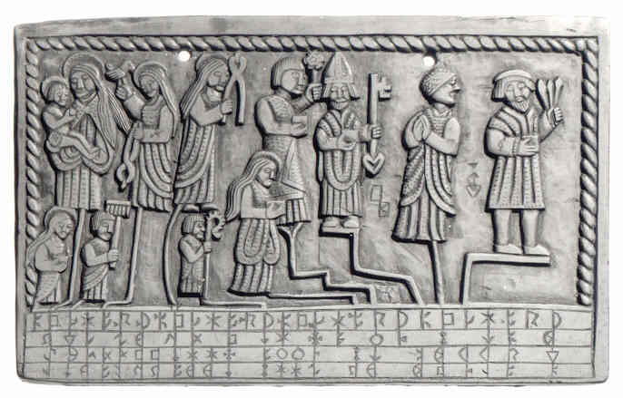
Plate 17. Bologna ‘runbok’ calendar: tablet 2, side B (February).
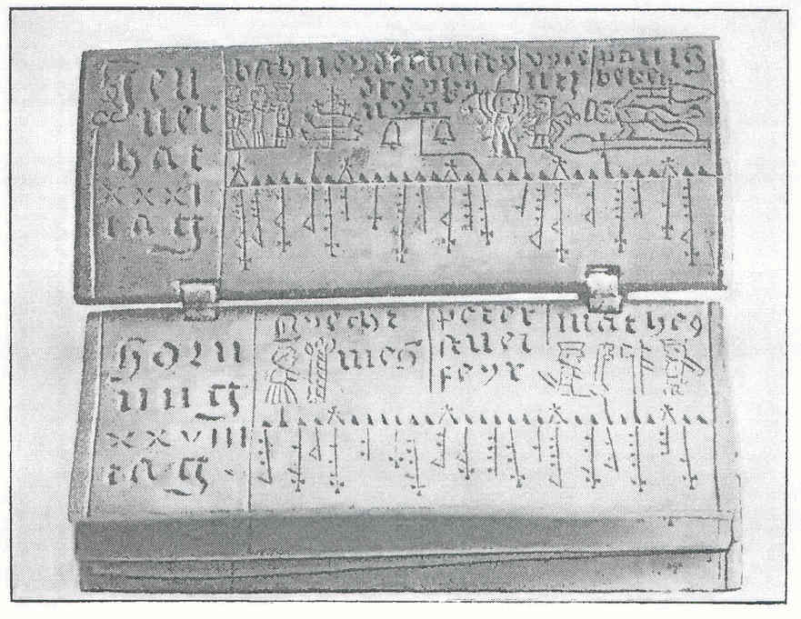
Plate 18. Wooden ‘rimbok’ from Pfronten, Bavaria (pages of January and February).
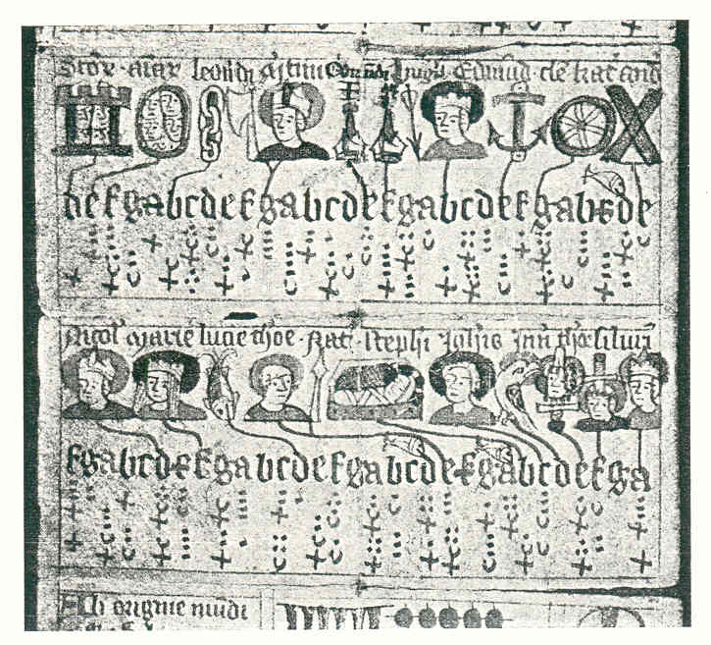
Plate 19. English parchment calendar from Basel (folding pages of November and December).

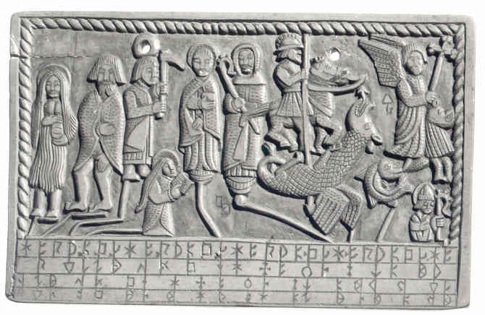
Plate 20. Bologna ‘runbok’ calendar: tablet 3, side B (April).
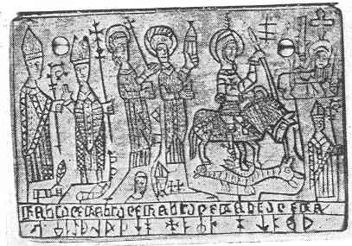
Plate 21. Paris ‘runbok’ calendar (page of April).

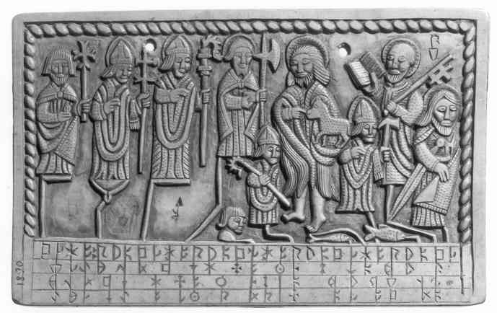
Plate 22. Bologna ‘runbok’ calendar: tablet 4, side B (June)
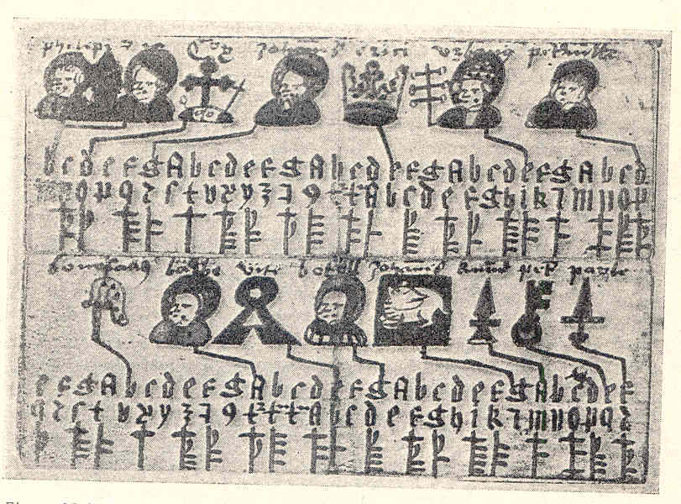
Plate 23. Erik’s XIV pocket calendar (folding pages of May and June)

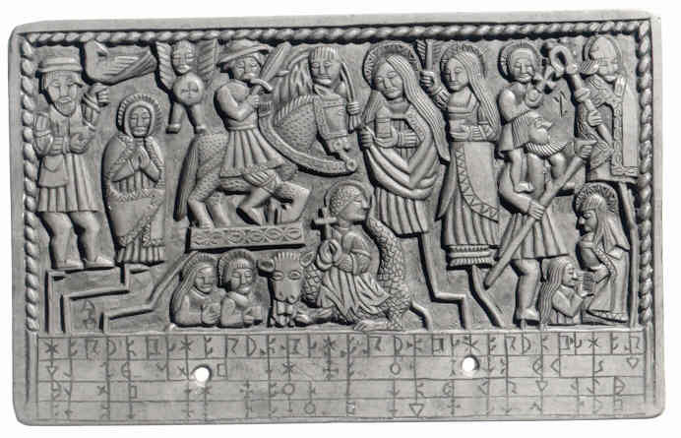
Plate 24. Bologna ‘runbok’ calendar: tablet 5, side A (July).
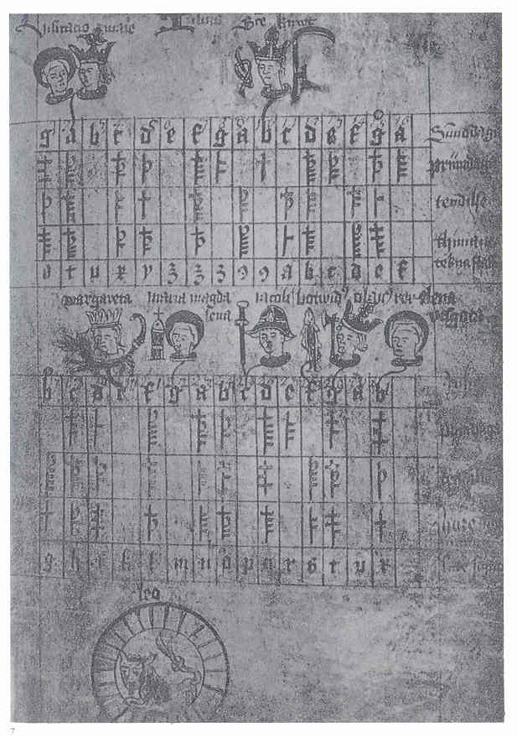
Plate 25. Linköping calendar (page of July).

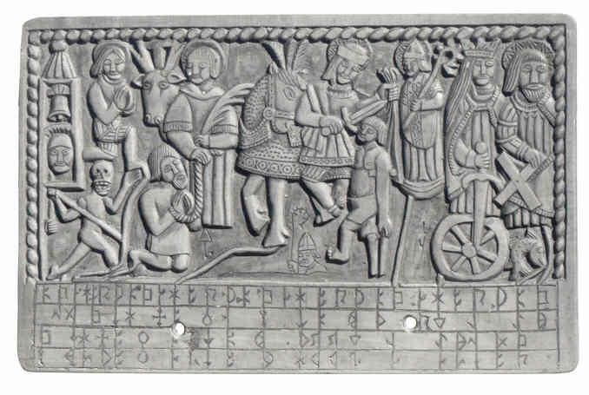
Plate 26. Bologna ‘runbok’ calendar: tablet 7, side A (November).
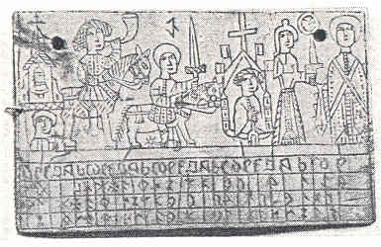
Plate 27. Copenhagen ‘runbok’ calendar
(page of November).

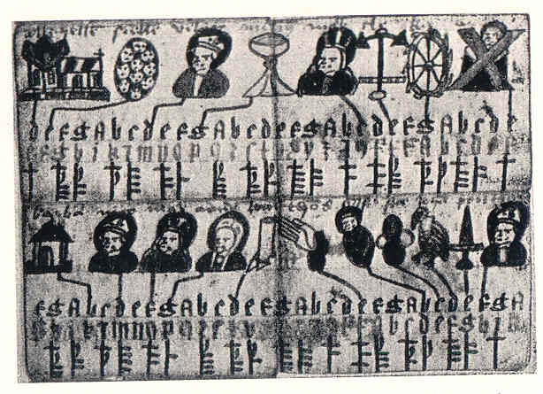
Plate 28. Erik XVI’s Almanac (folding pages of November and December).

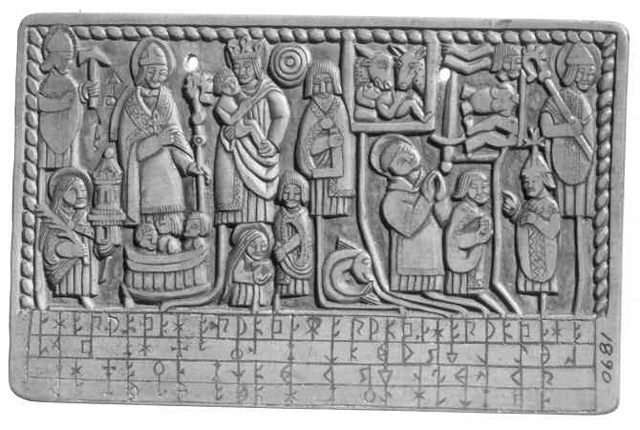
Plate 29. Bologna ‘runbok’ calendar: tablet 7, side B (December).

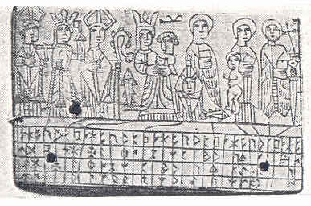
Plate 30. Copenhagen ‘runbok’ calendar
(page of December).
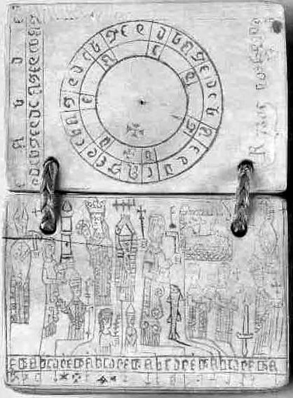
Plate 31. Paris ‘runbok’ calendar (page of December and Sunday letters cycle).
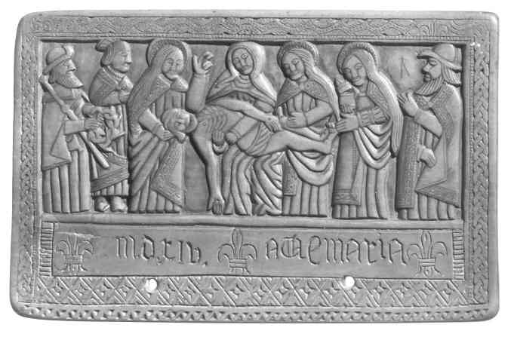
Plate 32. Bologna ‘runbok’ calendar: tablet 1, side A (front cover).
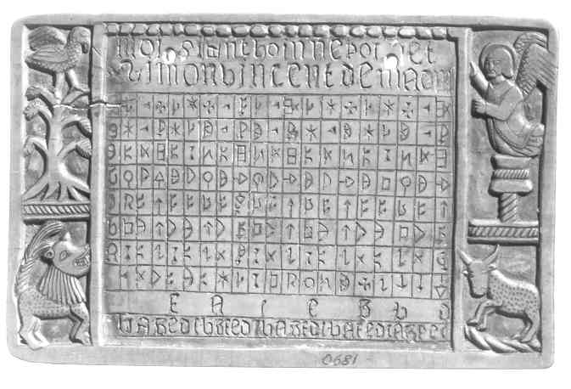
Plate 33. Bologna ‘runbok’ calendar: tablet 1, side B (Easter table).

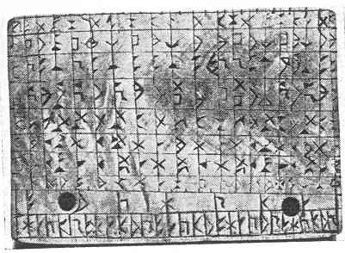
Plate 34. Paris ‘runbok’ calendar (Easter table).
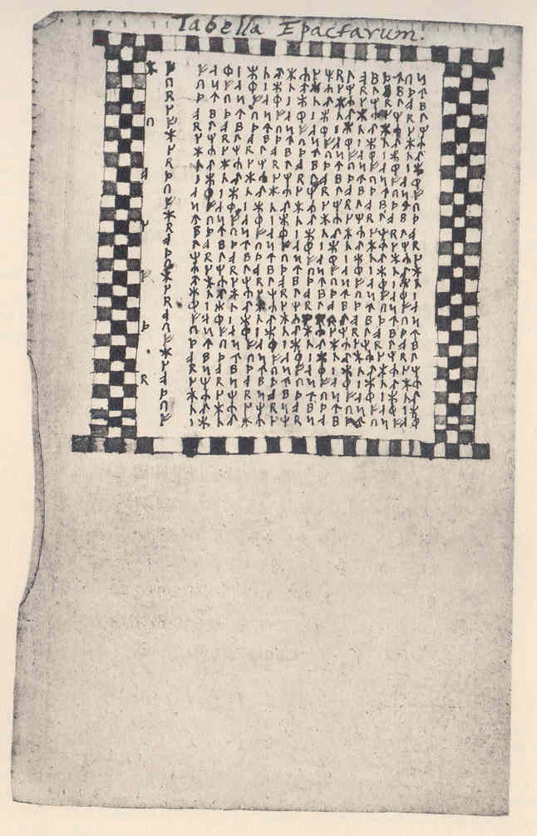
Plate 35. Tabula Paschalis in Gotland runic calendar 1328 (Ole Worm’s draft).

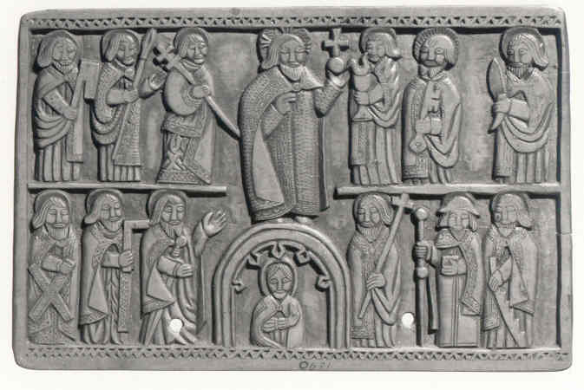
Plate 36. Bologna ‘runbok’ calendar: tablet 8, side A (back cover).
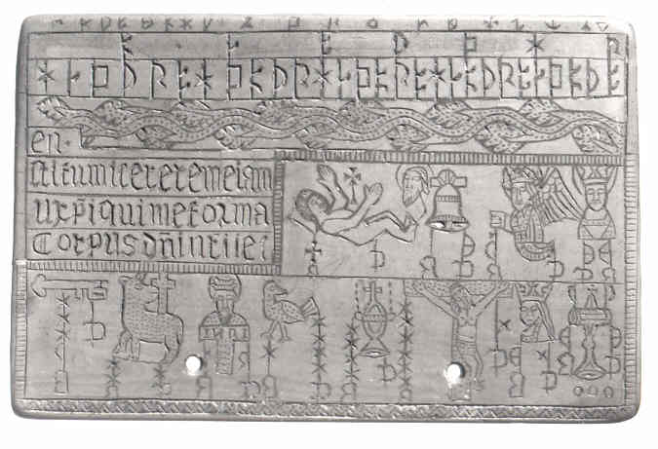
Plate 37. Bologna ‘runbok’ calendar: tablet 8, side B (inside back cover).

